Sandbox Simulation with FSM: Proposal  
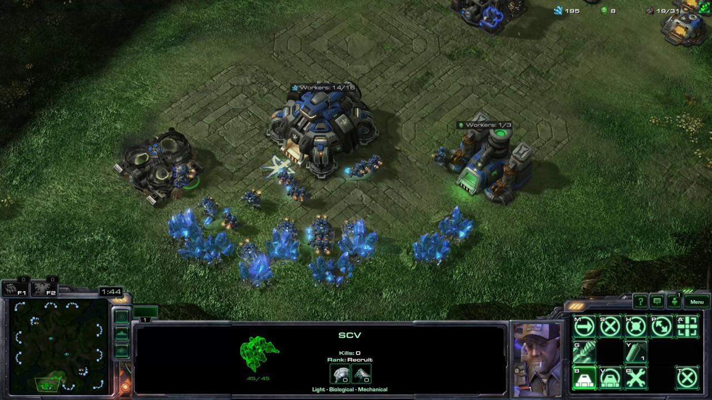

**Game suggestion: Starcraft**

Map:

* Base
  + Spawns units (Harvester, Patroller, Repairer)
* Minerals spawn at set locations in the simulation
  + - Mineral can be mined several times before it is depleted
    - If a Mineral is depleted, a new Mineral will spawn in a random position on the map.
* Enemies (Enemy) spawn randomly around edges of map throughout simulation

Units:

* ***(DEAD)***
  + *If any units’ HP reaches 0, it is destroyed and it leaves behind remnants*
  + *When Unit (exception: Enemy) is repaired, go back to* ***MOVING/PATROLLING***
* Harvester
  + **(MOVING)** 
    - If Harvester is carrying Minerals, move back to base
    - Else, harvester will move towards a random Mineral.
      * If Harvester reaches target (simple dist. check), go to **HARVESTING** state
  + **(HARVESTING)**
    - If Harvester is uninterrupted while mining, obtain Mineral and go back to **MOVING** state.
* If Harvester is attacked while in **MOVING/HARVESTING** state, go to **ATTACKED** state
* **(ATTACKED)**
  + Move quickly and away from the enemy
  + If nearest enemy is far enough, go back to **MOVING** state
  + If Harvester is HP reaches 0, goes to **DEAD** state
  + If Harvester reaches base, unload any Minerals it has on it
* Patroller
  + **(PATROLLING)**
    - Patroller follows a set path
      * If Patroller has an enemy in its range, **ATTACK** it
      * Once enemy is destroyed, Patroller continues patrolling
  + **(ATTACKING)**
    - Patroller shoots at target
    - If enemy is destroyed OR leaves Patroller’s range, go back to **PATROL**
  + If Patroller’s HP reaches 0, goes to **DEAD** state
  + If Patroller reaches base, despawn
* Repairer
  + **(MOVING)**
    - Moves towards nearest unit at **DEAD** state
    - When Repairer is close enough, **REPAIR** the unit
    - If unit is attacked, move to **ATTACKED** state
  + **(REPAIR)**
    - If unit is attacked, move to **ATTACKED** state
    - Once destroyed unit is repaired, go to **MOVING** state.
  + **(ATTACKED)**
    - Run away for 2 seconds
      * After running for 2 seconds, if HP is low, go to **RETREATING** state
      * Else, go back to **MOVING** state
  + **(RETREATING)**
    - Move back towards base
    - Once it reaches base, despawn.
* Enemy
  + **(MOVING)**
    - If a unit is detected, go to **ATTACKING** state
  + **(ATTACKING)**
    - If the enemy unit is destroyed or out of range, return to **MOVING** state
    - If Enemy HP reaches 0, despawn Enemy from game.